

Overview

The caCORE Software Development Kit (caCORE SDK) is NCI CBIIT’s toolkit that generates a data management framework to allow researchers to navigate through a large number of data sources. A caCORE SDK generated system is built on the principles of Model Driven Architecture (MDA), n-tier architecture and common APIs. This framework allows for easy access to data by other applications in either a secured or a non-secured fashion. When the caCORE SDK generated system is combined with controlled vocabularies and registered metadata, the resulting software system, called “caCORE-like” system, is “semantically integrated”. All exposed API elements of the generated system have runtime accessible metadata defined using controlled terminology.

SDK System Generation Process SDK Generated Systems on caGrid

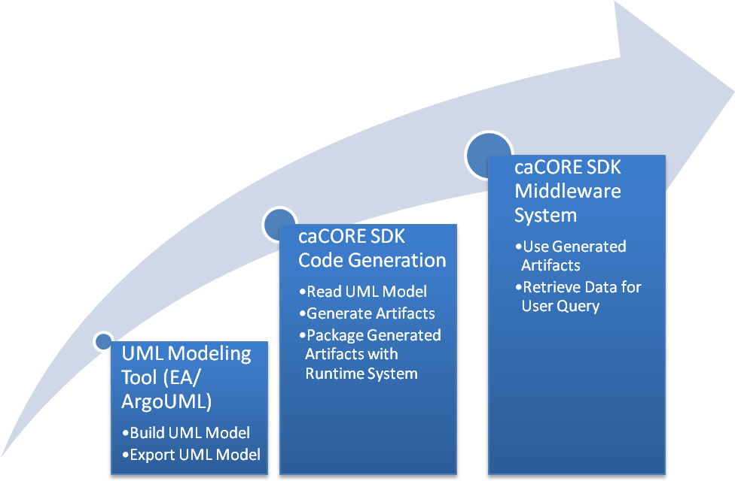 | 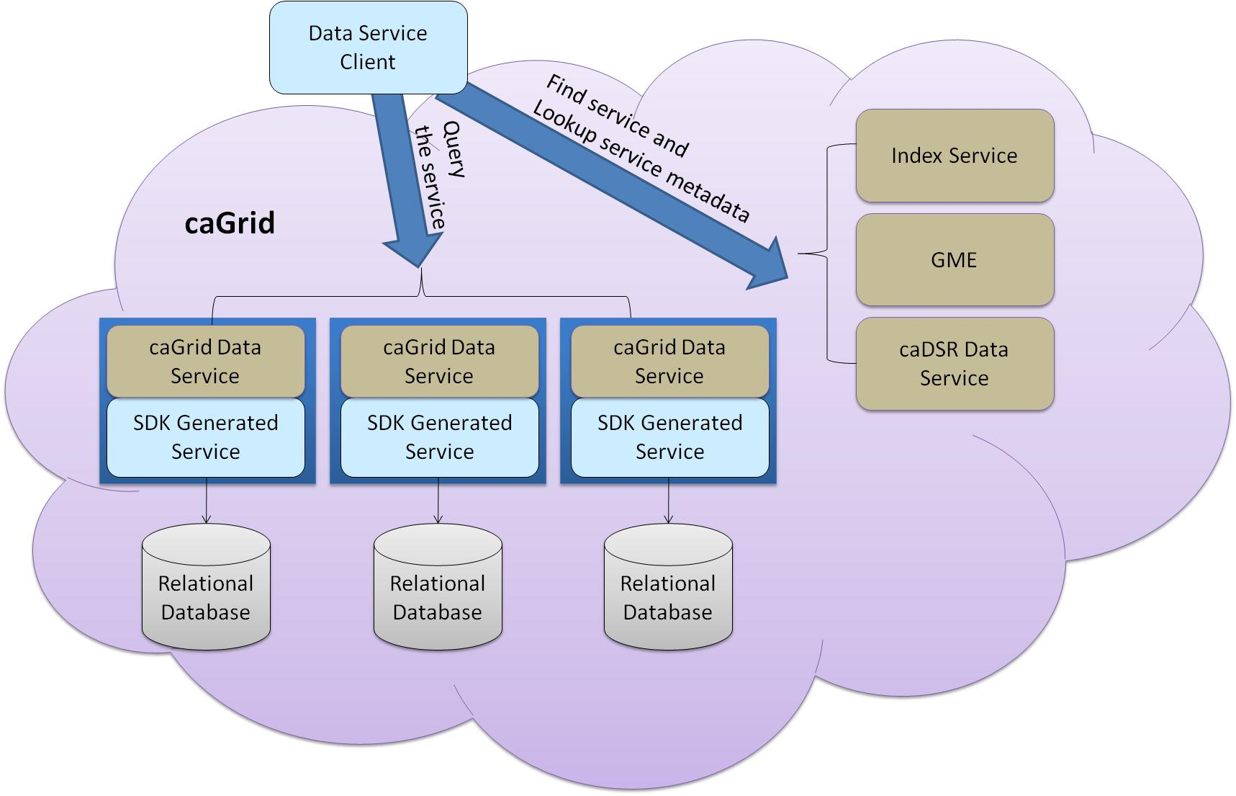
SDK Features

- Rapid generation of a caBIG® silver level compatible system
- Facilitate caBIG gold level compatible system generation with the caGrid tools
- Provides various interfaces to access underlying database
- Standardized Query By Example (QBE) based data access interfaces built on the application’s domain model
- Supports ArgoUML and Enterprise Architect UML models
- Ability to write to the remote data source using Java API
- Integrated security with the Common Security Module (CSM)

Upcoming SDK 4.2 Features

- Included with the caCORE workbench to manage multiple code generation and deployment configurations from it’s GUI interface
- Single command automated build and deployment for the generated application
- Automatically downloads and fully configures a Jboss or Tomcat server as a part of the deployment process
- Reconfigures the generated application to deploy into a new environment without regenerating the entire application
- Ability to deploy the application in a local or remote machine

Important Links

caCORE SDK: https://cabig.nci.nih.gov/tools/caCORE_SDK
GForge: https://gforge.nci.nih.gov/projects/cacoresdk/
Mailing List: CACORE_SDK_USERS-l@list.nih.gov

Continued on page 2
SDK Generated Middleware System Architecture

